Audio-Visual Entrainment: The Application of Audio-Visual Entrainment for the Treatment of Seasonal Affective Disorder
David Siever, Edmonton, Alberta, Canada

Abstract: Seasonal Affective Disorder (SAD) strikes all people from all nations, not just those near the poles of the earth as might be thought. The treatment of SAD has traditionally involved the use of anti-depressants, and more recently, light box therapy. Audio-Visual Entrainment (AVE) has also been shown to be beneficial in the treatment of this genetically based affective disorder and its related anxious/depressive/dietary conditions.

Introduction

Each year, 6% of northern populations are affected with Seasonal Affective Disorder (SAD) and another 14% have a milder form of SAD, called the winter blues. Surprisingly, SAD may occur at any time of year and in equatorial regions although the ratio of northerners with SAD as compared to those living in the tropics is about 10-1. People in the southern USA experience SAD in the summer from staying indoors where air conditioning allows them to escape the unbearable summer heat. People have also experienced SAD moving into a basement suite or an office on the north side of a building or after painting the interior of their home a darker shade of color. People have experienced SAD following the development of cataracts or after wearing sunglasses for an extended period of time and during overcast, rainy periods (Rosenthal, 1993).

The common symptoms are depression, anxiety, extreme fatigue, hypersomnia, carbohydrate cravings, and weight gain. Women between the ages of 20 to 40, their sexually reproductive years, are most susceptible (Rosenthal, 1993). The first controlled study using light therapy to treat SAD was published in 1984. SAD was officially accepted as a clinical malady in 1987 by the American Psychiatric Association and described in its then current diagnostic manual, the DSM-III-R. Since that time, a great number of studies on the topic have been completed.

Animals are more sensitive to the seasons than humans, as they go through migration, mating, molting and hibernation. For instance, hamsters can sense the difference between a 12-hour day when their gonads don’t grow versus a 12-hour and 15 minute day when their gonads begin growth. It is thought that humans aren’t as sensitive as animals because humans originated in and around Africa where solar fluctuations are much more minimal than those near the Earth’s poles (Wright, 2002).

Tick-Tock Goes the Clock

It must be understood that circadian timing has nothing to do with the sense of time lapsing between events, nor the ability to notice differences in timing between two events, such as two tone-bursts or other sensory stimulation. Stimulation from events initiates an attentional cortical reset, which in turn synchronizes brain activity. More specifically, about 300 milliseconds later, the brain generates an attentional spike known as the P300 response. This spike starts a timing loop, initiated in the substantia nigra, a part of the basal ganglia, which in turn sends a burst of the neurotransmitter dopamine to another part of the brain called the striatum. The striatum contains “spiny” cells, which oscillate at different frequencies. Over time, the differences or “beats” add up. When attention is once again initiated, the count is recorded, providing a “time stamp” for that interval, which higher levels of the brain then interpret into a sense of timing (Wright, 2002).

The Captain and Pineal

All species studied to date, from single-celled organisms to humans, have been observed to have a biological clock. This clock is essential for survival, regulating various types and levels of arousal to provide cues for alertness, eating, sleep and the release of hormones. Light waves striking the retina activate electrical output that is sent down the optic nerve to the brain for visual processing. A secondary, smaller nerve tract from the retina, originating from specialized cells that utilize a light detecting pigment called melanopsin, also carries signals to the suprachiasmic nucleus (SCN) of the hypothalamus. The SCN, in turn, sends nervous outputs to various parts of the brain including the pineal gland. Four genes that govern circadian cycles in flies, mice and humans have been discovered that not only reside within the SCN, but in all cells of the body. When cultured in a petri dish under constant lighting, these cells continue with gene activity, hormone secretion and energy production in a 24-hour cycle that varies less than 1% (Wright, 2002).

In the mid 70s, Dr. Alfred Lewy of the National Institute of Mental Health (NIMH) discovered the neurotransmitter melatonin. The wake/sleep cycle in animals and humans is controlled by melatonin, which is produced by the pineal gland, a structure the size of a pea and located in the mid-brain. Every night, the pineal gland excretes melatonin into the bloodstream and continues to do so until dawn. However, under normal exposure to sunlight, secretions of melatonin follow the earth’s light/dark time frame and therefore more melatonin is typically released during the long dark hours of the winter months. Henceforth, the pineal gland is in charge or “captains” our wake/sleep arousal states.

Knowing if We Have SAD

Although most anxiety and depression inventories could be used to detect SAD, one popular SAD test is the Seasonal Pattern Assessment Questionnaire or SPAQ, developed by Rosenthal and his colleagues at the NIMH. The SPAQ is a self-assessment questionnaire that evaluates one’s level of SAD from four basic categories:

1) Pattern of seasonality
2) Degree of seasonality
3) The degree that seasonal changes are a problem for you
4) Evaluating other related information
SAD and Brain Function

Few PET or SPECT studies of brain metabolism in SAD persons have emerged and they are inconsistent in results. Both Cohen, et al’s, (1992) positron emission tomography (PET) study and a single photon emission computerized tomography (SPECT) study by Murphy, et al. (1993) were inconsistent in results. The results of electroencephalographic (EEG) studies are also inconsistent and involve few electrode sites (Volf & Passynkova, 2002). One such study suggests increased left frontal alpha activity as compared to the right (Allen, et al., 1993), which is consistent with common understandings of depression. Another found all activity except alpha was higher in the left posterior region (Teicher, et al., 1996) while another study showed increased theta-alpha at C3 (Cajochen et al., 1996). Volf sought to finally put the debate to rest by comparing 16 site QEEGs of 31 depressed SAD patients against those of controls. Barring technical issues (a digital filtering concern of aliasing error, possibly invalidating all data, arises within the study), he found asymmetries of delta, theta and alpha involving heightened EEG activity in the right parietal and temporal regions. An asymmetry of heightened beta EEG occurred in lateral frontal regions (F7 & F8).

Treatment

A number of coping techniques are used to reduce the symptoms of SAD. These include long walks outside, aerobic exercise, a diet rich in complex carbohydrates and protein, relocating to sunnier locations, winter vacations to tropical areas, and frequenting sun-tanning centres. Light-based clinical interventions include light box therapy and audio-visual entrainment.

“Light box” therapy has been used to reduce the symptoms of SAD in 60% to 80% of SAD patients (Lam, 1999). White light therapy, using intensities of 2,500 lux, requires exposure times from 2 to 6 hours, a considerable behavioral investment for the user (Terman, et. al., 1989). Light exposures in the intensity of 10,000 lux for 30-minute exposures has been found to be more effective than 2,500 lux intensity with exposure times of several hours (Terman, et.al., 1990). Some people have reported that over-use of light therapy can leave them feeling “wired” and restless (Rosenthal, 1993).

Audio-Visual Entrainment (AVE) using flashing lights and pulsing tones has been shown to enhance EEG activity at the stimulation frequency. However, a lesser known attribute of AVE lies in its inhibition effect at roughly the half-frequency of stimulation (Siever, 2003). In QEEGs (brain maps) collected at our office of those with SAD, we have observed long spindles of 10 Hz alpha brain wave activity, globally, with particularly increased activity in the left frontal regions, consistent with Allen’s findings. In light of these findings, we had chosen to utilize 20 Hz AVE as a treatment modality for SAD.

SAD Study Using Audio-Visual Entrainment

Method

The Digital Audio-Visual Integration Device (DAVID) Paradise by Comptronic Devices Limited (now Mind Alive Inc.) was used in a 4-week randomized study of 74 SAD sufferers (52 females and 22 males, avg. age = 38.5 years) to reduce the symptoms of SAD through the application of AVE. The participants were screened according to the DSM-IV, SAD requirements. The study accepted participants from Edmonton, Alberta at roughly 53.5 northern latitude from November 1998 to March 1999.

Procedure

The Beck Depression Inventory (BDI) and the Anxiety Sensitivity Index (ASI) were used for the pre-test, post-test (placebo), and the post-post-test (treatment) results. A daily diary was maintained to record total sleep time, sociability at work and with the family, eating, appetite and carbohydrate intake, cravings, energy and body weight.

The participants were divided into two groups: a Control Group (CG) that did not receive the DAVID AVE unit and the Treatment Group (TG) that received “placebo” and treatment sessions. The Treatment Group received sub-delta (placebo) frequencies of 1 Hz for 2 weeks followed by beta frequencies (treatment sessions) of 20 Hz for 2 weeks. Fifty-eight treatment participants and 16 control participants finished the study. Paired t-tests were used in the within group measurements, and the analysis of variance (ANOVA) was used in the between group measurements.

Results

The pre-test BDI score for both groups was 20.1. A score above nine indicates at least mild depression. Depression within the CG increased by 28% to a score of 26.1. A reduction in depression for 36% of the participants was observed in the TG during the placebo condition and during actual treatment (the beta AVE group) 100% of the participants had reduced depression (BDI = 7.3, p<0.001), as shown in Figure 1.
Figure 1 Comparison of BDI scores between controls, placebo & treatment groups

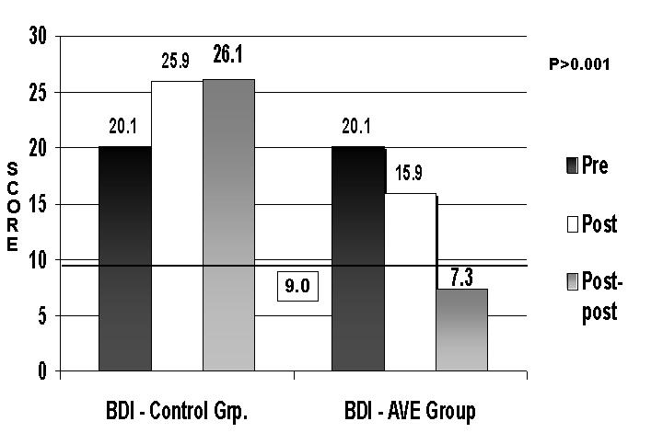

Of these, 84% became clinically non-depressed. The AVE male population anxiety sensitivity (AS) decreased significantly from 21% to 60% (p<0.001) from post to post-post, respectively while the control male population had a 7% increase in AS. The AVE female population showed decreased AS, from 15% to 34% (p<0.001) from post to post-post respectively, while the control group showed a mild reduction of 6%.

Figure 2 Comparison of ASI scores between pre, post and post-post results.

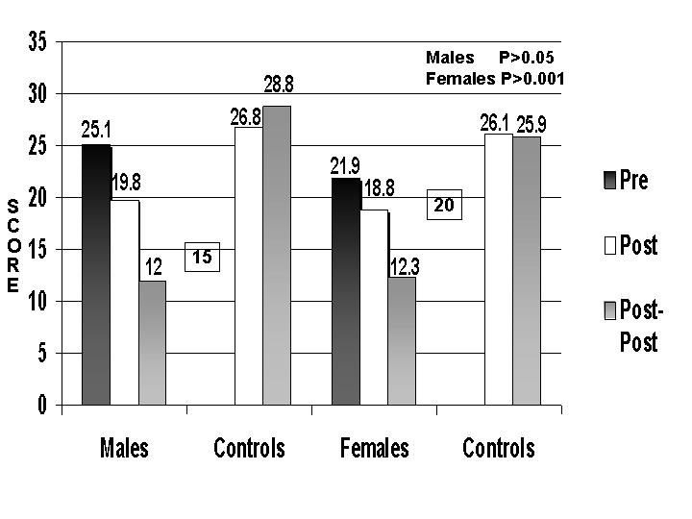
Daily diary results (Figure 3) indicated marked improvements. Positive moods improved by 20%. Sociability at home with the family and at work improved by 22% and 40% respectively.
Figure 3 Comparison of measures from pre to post-post conditions.

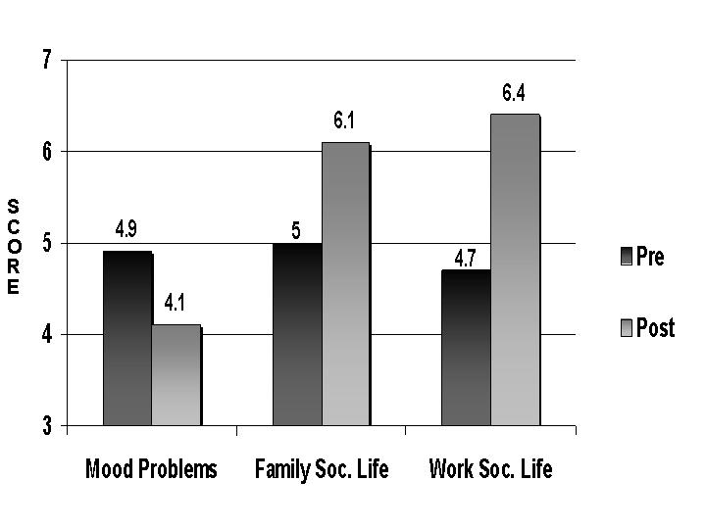

As shown in Figure 4, AVE participants’ food intake changed; over eating decreased by 18%, appetite decreased by 12%, and carbohydrate intake decreased by 15%. The participants also reported happiness with their increased energy (average increase of 18%).

Figure 4 Comparison of pre and post-post measures.
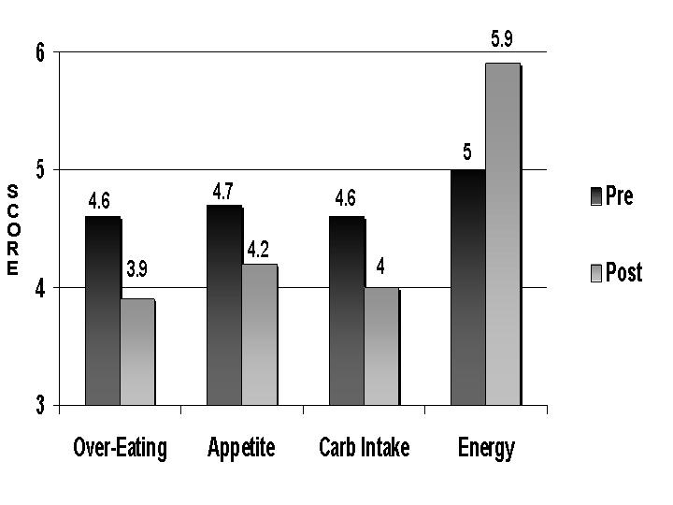

The daily diary results also showed that by using AVE, some participants lost considerable weight. A group of 12 participants (8 females and 4 males) reported that their average weight gain during the winter months was 15 pounds. During the placebo condition, they had an average weight loss of 3 pounds (1.36 Kg) plus an additional average weight loss of 6.5 pounds (4.3 Kg) during the two-week treatment condition.

Conclusion

White light AVE at 20 Hz produced significant results. Although sub-delta frequencies are non-effective at generating entrainment, sub-delta frequencies can affect both dissociative mind states and cerebral blood flow (Fox & Raichle, 1985). In addition, the “placebo effect” could also explain the sub-delta significance. The “placebo effect” has been shown to reduce anxiety, increase endorphin production, conditioning, and expectancy (Godfroid, 1998). Being that inadequate light elicits depression in SAD sufferers, the “placebo effect” via photic stimulation is possible.

The AVE Group’s depression decreased while the Control Group’s depression increased. Sensitivity to anxiety decreased in both male and female AVE groups. Although the female control participants had decreased sensitivity to anxiety, the female AVE population showed significance between the 1 Hz and 20 Hz stimulation.

Most control group participants claimed that they gained weight whereas an additional benefit of AVE is weight loss. One participant claimed that, “after using the 20 Hz session for 2 weeks, the taste of sweets in my mouth was repulsive.” Follow-up reports indicate participants’ SAD symptoms returned within an average of 2 weeks after discontinuing use of the DAVID AVE device.

References

Allen, J., Locono, W., Depue, R., & Arbisi, P. (1993). Regional encephalographic asymmetries in bipolar seasonal affective disorder before and after exposure to bright light. Biological Psychiatry, 33, 642-646.

Cajochen, C., Brunner, D., Krauchi, K., Graw, P., & Wirz-Justice, A. (2000). EEG and subjective sleepiness during extended wakefulness in seasonal affective disorder: circadian and homeostatic influences. Biological Psychiatry. 47, (7), 610-617.

Cohen, R., Gross, M., Nordahl, T., Semple, W., Oren, D., & Rosenthal, N. (1992). Preliminary data on the metabolic brain pattern of patients with winter seasonal affective disorder. Archives of General Psychiatry, 49, 545-552.

Fox, P. & Raichle, M. (1985). Stimulus rate determines regional blood flow in striate cortex. Annals of Neurology, 17, (3), 303-305.

Godfroid, I. O. (1998). [Placebo II. Psychiagenia and the brain organization. Annales Medico-Psychologiques [French], 152 (2), 108-114.

Lam, R .W. (1999). Information about seasonal affective disorder (SAD). University of British Columbia/VHHSC Mood Disorder Clinic. Retrieved on www.psychiatry.ubc.ca/mood/md_sad.html.

Murphy, D. G., Murphy, D. M., Abbas, M., Palazidou, B., Binnie, C., Arendt, J., Campos Costa, D., & Checkley, S. (1993). Seasonal affective disorder: response to light as measured by electroencephalogram, melatonin suppression and cerebral blood flow. British Journal of Psychiatry, 163, 327-331.

Rosenthal, N. E. (1993). Winter blues: What it is and how to overcome it. New York: Guildford Press.

Siever, D. (2003). AVE session protocol guide for professionals. Available from Mind Alive Inc., Edmonton, Alberta, Canada.

Teicher, M., Glod, K., & Ito, Y. (1996). Hemispheric asymmetry of EEG and T2 relaxation time in seasonal affective disorder (SAD) pre and post-light therapy. In: SLTBR: Abstracts of the Annual Meeting of the Society for Light Treatment and Biological Rhythms. p. 9.

Terman, M., Terman, J., Quitkin, F., McGrath, P., Stewart, J., & Rafferty, B. (1989). Light therapy for seasonal affective disorder: a review of efficacy. Neuropsychopharmacology, 2, 1-22.

Terman, J., Terman, M., Schlager, D., Rafferty, B., Rosofsky, M., Link, M., Gallin, P., & Quitkin, F. (1990). Dentification, assessment, and treatment of seasonality in mood disorders. Psychopharmacology Bulletin, 26, 1, 3-11.

Volf, N. & Passynkova, N. (2002). EEG mapping in seasonal affective disorder. Journal of Affective Disorders, 72, 61-69.

Wright, K. (September, 2002). Times of our lives. Scientific American, 287 (3), 59-65.

Address all correspondence to David Siever at Mind Alive Inc. Toll Free: 1-800-661-MIND (6463), Ph: 780-465-6463. Address: 9008-51 Avenue, Edmonton, Alberta, Canada, T6E 5X4. Web: www.mindalive.com Email: info@mindalive.com

